Student Handbook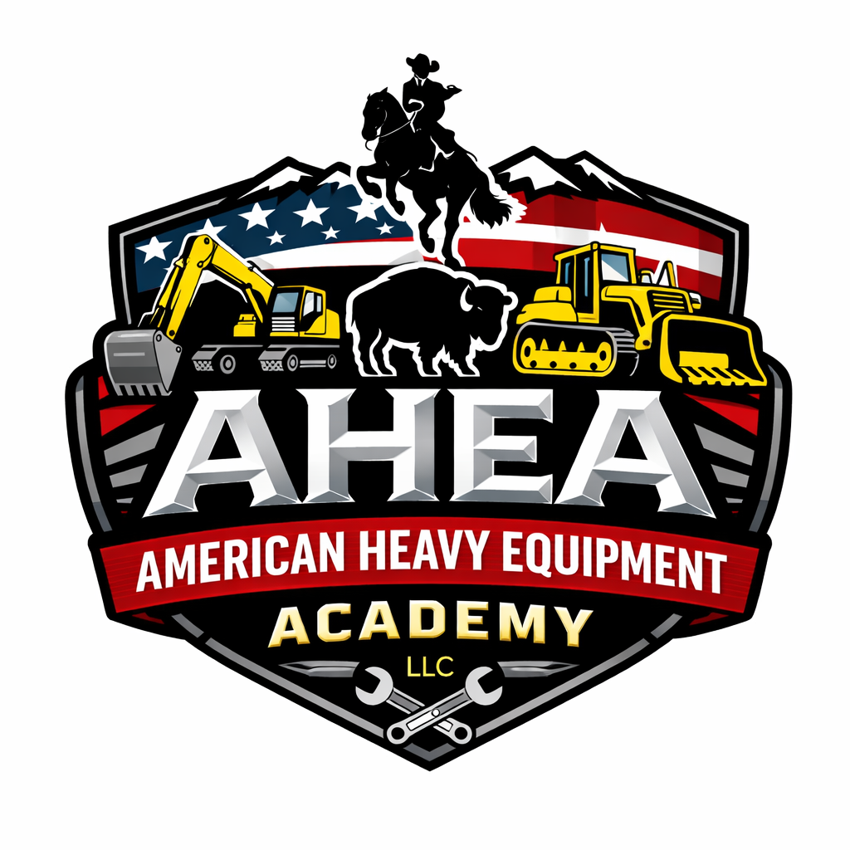

Preparing Operators for a Safer Tomorrow

American Heavy Equipment Academy LLC. (AHEA) delivers an intensive 8-week heavy equipment operator training program designed to prepare veterans and civilians for immediate employment in high-demand skilled trades. The program directly aligns with US and Wyoming workforce priorities and veteran transition needs.

Effective Date: June 24, 2026

Table of Contents
- Introduction
- Vision, Mission and Values
- Non‑Discrimination & Equal Opportunity Policy
- Program Description & Curriculum
- Admissions & Application Process
- Tuition & Expenses
- Code of Conduct & Ethics
- Attendance & Punctuality
- Safety & Personal Protective Equipment (PPE)
- Drug & Alcohol Policy
- Dress Code
- Technology & Social Media
- Health & Medical Policies
- Academic Integrity
- Privacy Rights & FERPA
- Grievance Procedure
- Program Completion & Certifications
- Changes to Policies
- Appendices

Introduction
Welcome to the American Heavy Equipment Academy (AHEA). This handbook has been prepared to inform prospective and current students about the mission of the Academy, the expectations for professional conduct, and the procedures that govern our training programs. Heavy equipment operation is a rewarding career that demands technical skills, safety awareness and a commitment to continuous learning. By reading and following the guidelines contained in this handbook, students will understand their rights and responsibilities as members of the AHEA community.

Vision, Mission and Values
Vision: To become the Premier American heavy equipment operator training academy in the Rocky Mountain region and the United States. Recognized for excellence in safety, skills development and job‑site readiness.
Mission: The American Heavy Equipment Academy prepares students for successful careers as heavy equipment operators by providing hands‑on training, classroom instruction and industry‑recognized certifications in a professional learning environment.
Values: AHEA is committed to safety, integrity, respect, fairness, equity and life‑long learning. We foster an inclusive culture that celebrates diversity and encourages collaboration among students, faculty and industry partners.

Non‑Discrimination & Equal Opportunity Policy
AHEA provides equal opportunity for training and advancement to all qualified individuals. Discrimination based on race, color, national origin, sex (including pregnancy, sexual orientation and gender identity), religion, age, disability, genetic information or other protected characteristics is prohibited. Our policies are grounded in federal and state civil rights laws, including Title IX of the Education Amendments of 1972, Section 504 of the Rehabilitation Act of 1973, the Americans with Disabilities Act (ADA) and the Equal Employment Opportunity Commission (EEOC) guidelines. Title IX prohibits sex‑based discrimination in education programs and ensures that no person shall be excluded from participation, denied benefits or subjected to discrimination based on sex in any education program receiving federal financial assistance. Section 504 and the ADA guarantee that no qualified individual with a disability shall be excluded or denied benefits in programs receiving federal funds. The EEOC guidelines prohibit discriminatory employment or apprenticeship practices based on race, color, religion, sex, national origin, age, disability or genetic information. AHEA will provide reasonable accommodation for students with disabilities in compliance with the ADA and Section 504. Students requesting accommodation should contact the Student Services Office prior to enrollment to discuss their needs.

Program Description & Curriculum
The Heavy Equipment Operator program at AHEA is a 320‑clock‑hour program designed to develop entry‑level skills in the operation and maintenance of construction equipment. Students receive hands‑on training on Skid Steers, Forklifts (Telehandler), Bulldozers, Backhoes, Wheel Loaders, And Excavators. Classroom instruction covers safety standards, soil mechanics, blueprint reading, grade staking and equipment maintenance. Upon successful completion, students may be eligible to earn industry credentials such as American Heavy Equipment Academy operator certification, the National Center for Construction Education and Research (NCCER) Heavy Equipment Operator certification, the OSHA 10‑hour safety card and the OSHA 30-hour safety (Construction Industry) card.
Training emphasizes safe operation. Pursuant to OSHA requirements for powered industrial truck operators, students must demonstrate competency through formal instruction, practical training and skills evaluation. Refresher training and evaluation are provided whenever unsafe operation is observed or when changes in equipment or workplace conditions occur.
Classes are taught by experienced instructors who bring real‑world experience from construction, mining and heavy civil industries. The curriculum is updated periodically to reflect industry standards and technological advances.

Admissions & Application Process
AHEA seeks motivated individuals who are committed to safety and professionalism. To enroll in the Heavy Equipment Operator program, applicants must meet the following requirements:
- Be at least 16 years of age on the first day of training.
- Must be able to read, write, and understand English
- Students must be able to lift and carry up to 50 pounds, climb ladders and equipment, and operate in various weather conditions.
- Pass a vision screening and meet minimum vision requirements for equipment operation.
- Submit to and be able to pass a drug screening at the discretion of the Academy.
- Complete the AHEA application form (Appendix A) and pay any required fees.
Applicants are encouraged to contact the Admissions Office for assistance with completing forms or obtaining medical examinations. Admission is contingent upon space availability and satisfactory completion of all requirements.

Tuition & Expenses
Tuition covers classroom instruction, hands‑on training and basic training materials. Students are responsible for the following expenses:
- Program tuition of $18,500 for the full 8 wk. course. See catalog for specific costs.
- Registration fee and deposit $200 (non‑refundable, may be moved to later date).
- Personal protective equipment (hard hat, safety vest, safety glasses and gloves) is provided by AHEA. Students must provide reenforced or steel toe boots.
- Textbooks and supplemental study materials.
- Transportation, lodging and meals (breakfast and lunch are provided Monday-Friday, and breakfast on weekends).
Tuition and fees are due before the start of the program unless a payment plan is arranged. AHEA participates in certain workforce development programs; students should inquire about funding options.

Code of Conduct & Ethics
AHEA expects students to conduct themselves professionally and to demonstrate respect for instructors, staff, classmates and equipment. The following code of conduct promotes a safe and supportive learning environment:
- Treat others with dignity and respect. Bullying, harassment or abuse of any kind is not tolerated.
- Practice honesty and integrity in all activities, including classroom assignments and testing.
- Encourage fairness and cooperation; strive to be a positive member of the academy community.
- Demonstrate good citizenship by following safety rules and maintaining a substance‑free environment.
- Respect academy property, equipment and facilities.
Failure to adhere to this code may result in disciplinary action, up to and including dismissal from the program.

Attendance & Punctuality
Regular attendance and punctuality are essential to success in the Heavy Equipment Operator program. Training is intensive and builds on prior lessons; absences disrupt learning and may compromise safety. Students must adhere to the following guidelines:
- Daily Training begins promptly at 8:00 AM and ends at 4:00 PM. Attend all scheduled classes and field exercises on time. If you are unable to attend, notify the instructor or Student Services as soon as possible.
- Arrive prepared with proper safety gear and ready to participate.
- Excessive absences or tardiness may result in disciplinary action and could jeopardize program completion.
- In cases of illness or emergency, provide appropriate documentation to Student Services for an excused absence.

Safety & Personal Protective Equipment (PPE)
Safety is the highest priority in heavy equipment operation. Students must follow all safety protocols and always wear appropriate personal protective equipment while on campus or job sites. Key safety policies include:
- Complete all OSHA‑required training modules and demonstrate competency through formal instruction, hands‑on practice and evaluation.
- Attend site‑specific orientation and hazard communication briefings.
- Wear the required PPE: hard hat, safety glasses, high‑visibility vest, long pants, long‑sleeved shirt (as conditions require), work gloves and steel‑toed/composite boots.
- Inspect equipment before use; report any malfunction or damage to the instructor immediately.
- Follow proper lockout/tagout procedures and respect safety barriers.
- Never operate equipment under the influence of alcohol, illicit drugs or prescription medications that impair your ability to operate safely.
AHEA reserves the right to remove students from equipment operation if unsafe behavior is observed. Refresher training will be provided as needed.

Drug & Alcohol Policy
AHEA maintains a drug‑free and alcohol‑free environment in accordance with federal and state regulations. Substance use impairs judgment and endangers the safety of students and staff. The following requirements apply:
- Random drug and alcohol testing may be conducted during the program.
- Use, possession, distribution or sale of illegal drugs or alcohol on academy premises or training sites is prohibited.
- Prescription medications must be used only as prescribed; notify your instructor if a medication could impair safe operation.
- Violations of this policy may result in immediate dismissal.

Dress Code
Students are expected to present a professional appearance and wear clothing suitable for construction environments. Recommended attire includes:
- Long pants made of durable material; shorts and open‑toed footwear are not permitted.
- Steel‑toed/composite boots or shoes that meet ASTM safety standards.
- High‑visibility safety vest or jacket (provided or approved by AHEA).
- Shirts with sleeves; tank tops and sleeveless shirts are not allowed.
- Hard hat and safety glasses (provided or approved by AHEA).
Students should avoid loose clothing, jewelry or accessories that could become entangled in machinery.

Technology & Social Media
Cell phones and personal electronic devices must not interfere with training. Instructors may require devices to be turned off or stowed during class. The following guidelines apply:
- Use cell phones or personal devices only during breaks or in designated areas.
- Do not operate machinery while using a phone or wearing headphones.
- Photography or video recording of equipment, training or proprietary materials requires prior permission from the instructor.
- Students should refrain from posting sensitive or confidential information about AHEA or training activities on social media.

Health & Medical Policies
Heavy equipment operation is physically demanding. Students must be healthy enough to meet the physical requirements identified in the admissions section. Students should disclose any medical conditions that could affect safety.
- Provide current emergency contact information to Student Services.
- Report injuries or illnesses that occur during training to the instructor immediately and complete an incident report.
- Students are encouraged to obtain health insurance coverage.
- In the event of a medical emergency, AHEA will seek immediate medical attention. Students are responsible for any associated costs.

Academic Integrity
AHEA upholds the highest standards of academic integrity. Cheating, plagiarism, falsification of records or assisting another student to commit these acts is strictly prohibited. Violations may result in disciplinary action, including dismissal from the program.
- Complete your own tests, quizzes and assignments.
- Do not share exam answers or materials without permission.
- Cite sources appropriately when using information from manuals or external references.
- Report suspected academic dishonesty to the instructor.

Privacy Rights & FERPA
The Family Educational Rights and Privacy Act (FERPA) protects the privacy of student education records. Students have the right to inspect and review their records and to request amendments to records they believe are inaccurate or misleading. AHEA will not disclose personally identifiable information from student records without written consent, except as permitted by law. When consent is required, the written authorization must specify the records to be disclosed, the purpose of the disclosure and the party to whom the disclosure may be made. Students wishing to grant access to their records must complete the Release of Student Information form (Appendix G).

Grievance Procedure
AHEA is committed to addressing concerns and resolving complaints in a fair and timely manner. Students who believe they have been subjected to discrimination, harassment or unfair treatment may file grievance using the following procedure.
- Attempt informal resolution by discussing the concern with the instructor or staff member involved.
- If unresolved, submit a written complaint to the Student Services Office within 10 days of the incident. The complaint should describe the issue, relevant facts and desired resolution.
- The Student Services Office will investigate and respond in writing within a reasonable timeframe.
- If the matter is not resolved, the student may appeal to the Academy Director
- Whether or not the problem or complaint has been resolved to his/her satisfaction by the school, the student may direct any problem or complaint to the Wyoming Department of Higher Education: 122 W. 25th St, Ste E200, Cheyenne, WY 82002, (307) 777-7675
Retaliation against any person who files a grievance or participates in an investigation is strictly prohibited.

Program Completion & Certifications
Students who successfully complete all program requirements, including attendance, hands‑on evaluations and written examinations, will receive a Certificate of Completion from AHEA as well as wallet size license depicting the pieces of equipment certified on. Students may also be eligible to earn the NCCER Heavy Equipment Operator credentials and license. And the OSHA 10‑hour safety card as well as the OSHA 30-hour (Construction Industry). Certification signifies that a student has met the standard of competency for entry‑level equipment operators.
Employers may require additional experience, endorsements or state licensing prior to employment. Students are encouraged to maintain copies of certificates and transcripts for their records.

Changes to Policies
AHEA reserves the right to revise the policies and procedures contained in this handbook at any time. Students will be notified of changes as they occur. The most recent version of the handbook supersedes any previous versions.
Future Class Schedule
Here are the start dates for the entire 2027 calendar year. Whether you’re
taking the full course or a custom course, these are the set start dates for our Programs.
2027 Start Dates – Heavy Equipment

March 1st 2027
May 3rd 2027
July 5th 2027
September 6th 2027
November 1st 2027

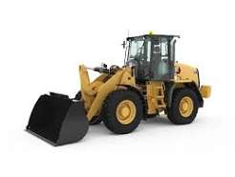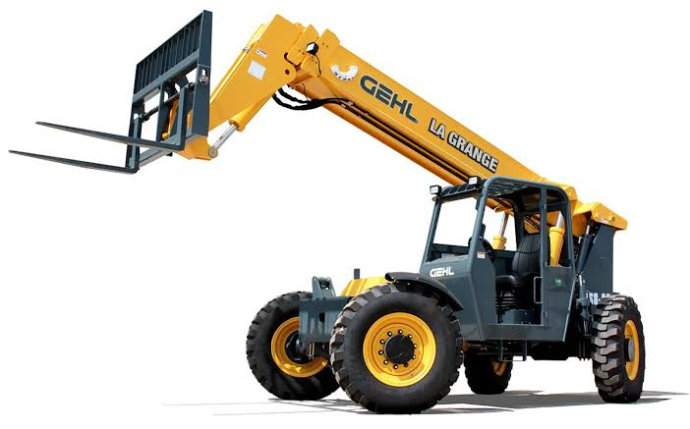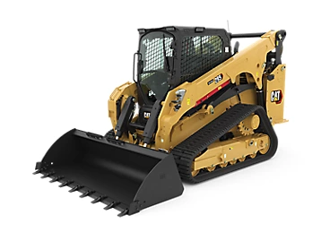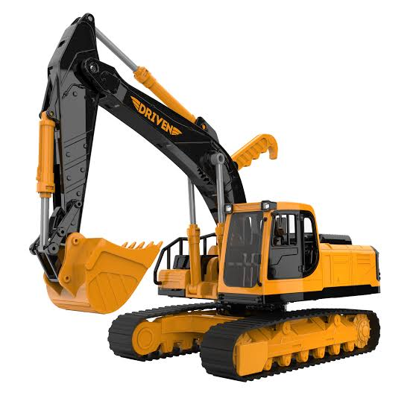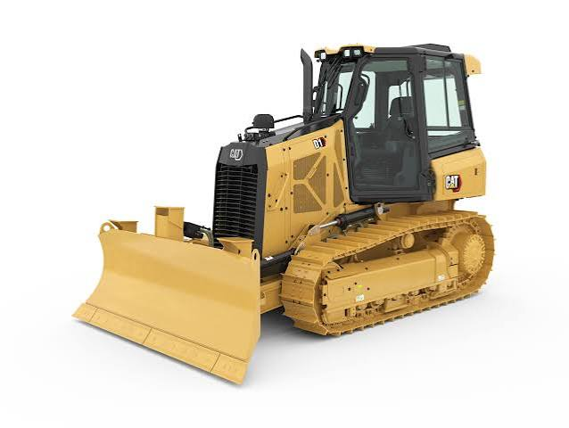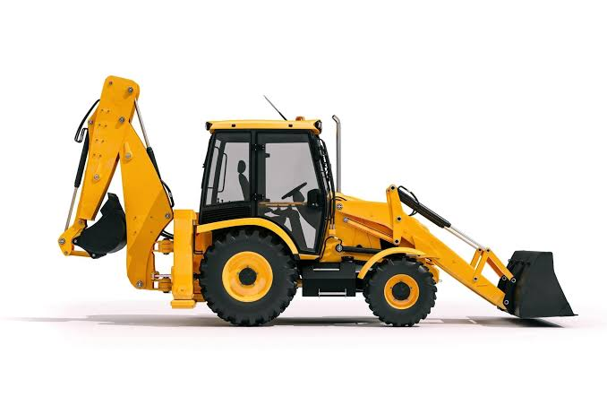

Courses – Overview & Cost
American Heavy Equipment Academy (AHEA) offers an intensive 8-week Heavy Equipment Operator Program beginning March 1, 2027. Tuition is $18,500 and includes lodging, daily breakfast, Monday–Friday lunch, OSHA 10, OSHA 30 (Construction Industry), operator certification on Dozer, Excavator, Backhoe, Wheel Loader, Skid Steer and Telehandler, with the opportunity to earn NCCER certifications on qualifying equipment.

8-Week Program Overview
Students receive classroom instruction and extensive hands-on training emphasizing safety, equipment inspection, preventive maintenance, grade reading, jobsite communication, and professional operator development. Training prepares graduates for entry-level employment in construction, mining, oil & gas, utilities, transportation, and heavy civil industries.
Custom 4-Week Program- This program is designed for individuals who already know what specific piece of equipment they want to or are going to be working on the dozer is a difficult piece of equipment to master, but our program is a strict 4-week intense course that focuses solely on the chosen piece of equipment. work.
Prices for this program- $10500
Equipment Certifications Included:
• Duration: 4 Weeks – 160 Hours
• Over 80 Hours of Hands-on Training • Bulldozer, Excavator, Wheel Loader, or backhoe or skid steer/ Telehandler • 80 Hours of classroom work.
• Training Includes:
OSHA 10-OSHA 30- Blueprints, Grading, JSA’s, Site Planning, Trenching,
Bell holes, Steps, Beaver Slides, Equipment Inspections, various attachments and more.

Equipment Certifications
Students demonstrate proficiency on:
• Dozer
• Excavator
• Backhoe
• Wheel Loader
• Skid Steer
• Telehandler
Eligible students may also earn NCCER Heavy Equipment credentials in accordance with Academy requirements.

FUNDING-
www.mikeroweworks.org – Awards scholarships to anyone looking for a career in the trades, the application process is simple and only takes a few minutes.
www.bringbackthetrades.org – Awards scholarships every month and again, this one is only for tradesmen
Wyoming Vocational Rehabilitation Services - Offers scholarships for individuals with any sort of disability. For example, if you have ADHD, Anxiety, Dyslexia, or if you are on a 504 plan in high school, or if you have learning or hearing disabilities you may qualify. Give them a call at Phone: (307) 777-8650 and apply today.
Out of state? No problem. Every state has a vocational rehabilitation program.
Find the Rehab office closes to you here. https://rsa.ed.gov/about/states

WIOA- This is the Workforce Innovation and Opportunities Act. This is a federal grant that
helps students with education costs and is awarded to individuals based solely off
income. If you’re low income, you may qualify. Apply on their website at
www.ncaworks.com or give them a call at (501) 628-6650 for more info.

VA Post 9/11 GI Bill- Our school is not currently approved by the VA to accept veteran benefits.

Student Loans. AHEA is currently not approved to accept Federal student Aid (FAFSA)

We do however have some in-house financing options as well, so don’t let financial stress stop you from pursuing your dream job. Also, AHEA partners with a few local Banking institutions to assist with your financial needs.

Funding for the Attention women! Exciting opportunities await you through P.E.O. International, a Ladies organization dedicated to supporting women like you in acquiring the necessary training and education for a rewarding career as an operator. Benefit from their assistance in obtaining student loans at remarkably low rates, and don't miss out on their scholarship program, offering awards of up to $12,500! For more details, visit their website at P.E.O. International, or reach out to them directly at (515) 255-3153.

Receiving SSI or SSDI? Here is an incredible opportunity that not only funds your education but also Propels you towards a rewarding career as a heavy equipment operator. Tickets to Work is a program designed to empower individuals, offering financial independence and a pathway off of government dependency. What sets this program apart is its unique feature – you can maintain SSI benefits while actively participating in work and training. Explore further details and seize this chance for personal and professional growth. Check them out here - www.ssa.gov/work

Appendices
The following appendices contain forms that must be completed and submitted as part of the admissions process and ongoing compliance.

Appendix A – Student Application Form
Please complete all fields. Print clearly or type. Attach additional pages if necessary.
Full Legal Name:
________________________________________________________________________
Mailing Address:
________________________________________________________________________
City, State, ZIP:
________________________________________________________________________
Phone Number:
________________________________________________________________________
Email Address:
________________________________________________________________________
Date of Birth:
________________________________________________________________________
Social Security Number (last four digits):
________________________________________________________________________
Driver’s License Number and State:
________________________________________________________________________
Emergency Contact (name, relationship, phone):
________________________________________________________________________
Highest Level of Education:
________________________________________________________________________
Previous Experience with Heavy Equipment (describe):
________________________________________________________________________
Physical Limitations or Medical Conditions:
________________________________________________________________________
How did you hear about AHEA?
________________________________________________________________________
Certification and Signature: I certify that the information provided is true and complete to the best of my knowledge.
Applicant Signature: _________________________ Date: __________________

Appendix B – Physician Authorization Form
This form must be completed. Heavy equipment operation involves physical activities such as climbing, lifting, bending, twisting, and exposure to noise, vibration and weather extremes. Students must be medically fit to perform these tasks safely.
Physical Requirements (physician to complete):
☐ Able to lift and carry 50 pounds or more
☐ Able to climb ladders and equipment multiple times per day
☐ No restrictions on standing or walking for extended periods
☐ No conditions that would impair balance or coordination
☐ Vision meets requirements for driving and equipment operation
☐ Hearing sufficient to perceive backup alarms and equipment signals
☐ Able to tolerate outdoor environmental conditions (heat, cold, noise)
Comments or limitations: ______________________________________________________
______________________________________________________________________________
I certify that the student named above is medically fit to participate in the Heavy Equipment Operator program, with any noted restrictions.
Student Signature: _________________________ Date: __________________

Appendix C – Work Site Waiver & Liability Release
Participation in the Heavy Equipment Operator program involves exposure to risks inherent in construction and heavy civil environments. By signing this waiver, you acknowledge these risks and agree to assume full responsibility for your safety and any injury or property damage that may occur. You further agree to release and hold harmless AHEA, its owners, employees and agents from any and all claims arising from participation in training activities except as caused by gross negligence or intentional misconduct.
Participant Name: ________________________________________________
Signature: _________________________ Date: __________________
Witness (AHEA representative): ______________________ Date: __________

Appendix D – Drug Test Consent
I understand that enrollment in the Heavy Equipment Operator program is contingent upon successfully passing a drug test if necessary. I hereby consent to undergo urine or other specimen collection and testing for controlled substances and to the release of results to AHEA.
Participant Name: ________________________________________________
Signature: _________________________ Date: __________________

Appendix E – Honesty & Testing Agreement
I affirm that I will complete all examinations, quizzes and assignments honestly and without unauthorized assistance. I will not share or obtain answers during testing and will report any violations of academic integrity. I understand that cheating may result in dismissal.
Participant Name: ________________________________________________
Signature: _________________________ Date: __________________

Appendix F – Safety Agreement
Safety is paramount at AHEA. I agree to comply with all safety rules and instructions, wear required personal protective equipment, report hazards immediately and participate in safety training and drills. I understand that failure to follow safety protocols may result in disciplinary action or removal from training.
Participant Name: ________________________________________________
Signature: _________________________ Date: __________________

Appendix G – Release of Student Information (FERPA Consent)
Under the Family Educational Rights and Privacy Act (FERPA), AHEA must obtain written consent before releasing personally identifiable information from student records. This form authorizes AHEA to disclose specified records to a designated third party and or possible employer.
Student Name: ________________________________________________
Student ID (if applicable): ____________________________________
Person/Organization to Receive Information: _____________________
Relationship to Student: _______________________________________
Purpose of Disclosure: _________________________________________
Information to be Released (check all that apply):
☐ Academic records/transcripts
☐ Attendance records
☐ Medical or disability information
☐ Billing and financial information
☐ Other (specify): __________________________________
Authorization:
I authorize the release of the information specified above. This consent may be revoked at any time by providing written notice to AHEA, except to the extent that action has already been taken in reliance on it.
Student Signature: _________________________ Date: __________________

Appendix H – Transcript Release Request
Students may request official transcripts of their training record. Transcripts will be released only upon written request and payment of any applicable fees.
Student Name: ________________________________________________
Student ID (if applicable): ____________________________________
Address to Send Transcript: _____________________________________
City, State, ZIP: _____________________________________________
Number of Copies Requested: ____________________________________
Delivery Method (mail/pick‑up/email): _________________________
Student Signature: _________________________ Date: __________________

Appendix I – Student Handbook Acknowledgment
By signing this acknowledgment, I certify that I have received, read and understand the AHEA Student Handbook. I agree to comply with all policies, procedures and requirements contained therein. I understand that failure to do so may result in disciplinary action or dismissal.
Participant Name: ________________________________________________
Signature: _________________________ Date: __________________

